Digestive Systems Review
Agricultural Science 2
Hansen ’02

Label the parts of the ruminant stomach and identify their functions:
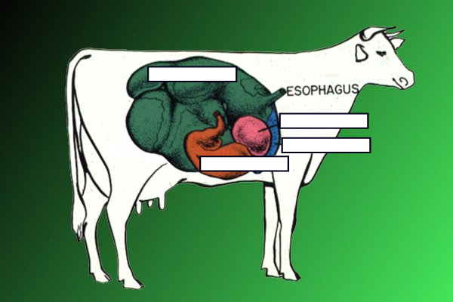

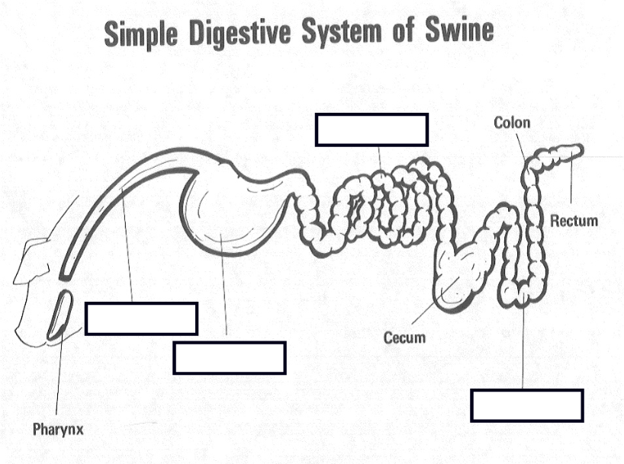Label the parts of the monogastric digestive system and identify their functions:

Label the parts of the horse digestive system that you did not identify on the pig and cow and identify their functions.
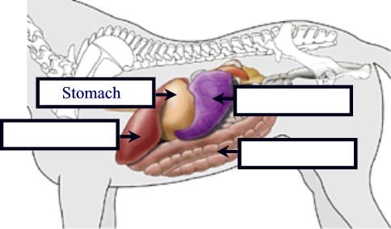

Finish the table
 | Swine | Horse | Cattle | Sheep
Mature Female
Mature Male
Castrated Male
Immature Female
Immature Male
Baby
Giving Birth

Identify the cell parts and functions.


